Integrating trait, phylogeny and environment to explore the causes of spatial and temporal variation in ecological networks

MS submitted to Ecology Letters in the “Perspective” category.

Catherine H. Graham1^* and Ben G. Weinstein2^

1Swiss Federal Research Institute (WSL), Birmensdorf, Zurich. [catherine.graham@wsl.ch](mailto:catherine.graham@wsl.ch)

2Department of Fisheries and Wildlife, Marine Mammal Institute, Oregon State University, 2030 Marine Science Drive, Newport, OR 97365, USA. weinsteb@oregonstate.edu

*Corresponding author

^ authors contributed equally to this work.

Running Title: Interaction beta-diversity

Keywords: Bayesian, evolutionary history, interaction beta-diversity, rewiring, scale, turnover

Abstract Length: 123

Main Text Length: 4010

Number of References: 85

Number of Figures: 4

Number of Boxes: 1

Authorship: CG, BW developed the conceptual ideas and wrote the MS.

Data Accessibility: Should the manuscript be accepted, we will place all data in DRYAD for archiving.

# ABSTRACT

Species interactions are fundamental to community dynamics and ecosystem processes. Despite significant progress in describing the connections among species, we lack a comprehensive view of when interactions should change across time and space. By focusing on interaction beta-diversity, which considers both spatial and temporal species turnover and the change in the intensity of interactions, we can connect changes in local interactions with regional biodiversity. Here we discuss the biological insights and methodological concepts surrounding interaction beta-diversity, as well as outline a Bayesian approach to predicting species interaction intensity based on the biotic and abiotic environment. Integrating statistical models of local interactions with biogeographic and evolutionary histories of co-occurring species will provide new insight into the mechanisms that drive variation in patterns of biodiversity.

# INTRODUCTION

Determining the causes and variation in biodiversity remains a core question of ecology and evolution. With a consensus that multiple mechanisms may lead to observed patterns of species co-occurrence (Mayfield & Levine 2010; Adler *et al.* 2013; Kraft *et al.* 2014), direct quantification of species interactions has become a common approach for identifying the mechanisms underlying local diversity (Vázquez *et al.* 2009). Yet, just as solely considering alpha-diversity of an assemblage limits our understanding of the regional processes that lead to species occurrence; evaluation of a single network is only snapshot of the dynamic nature of species interactions. Only by focusing on how interactions vary across spatial and environmental gradients can we identify their role in broader scale diversity patterns and dynamics (Poisot *et al.* 2015b; Pellissier et al. 2017). Interaction beta-diversity includes both the turnover in species, and the change in intensity of interactions among species (Novotny 2009; Poisot *et al.* 2012). In addition, species functional and phylogenetic relationships can be integrated into interaction beta-diversity to further develop models of biodiversity across space and time (Burkle *et al.* 2016).

Inspired by community assembly theory (Ackerly 2003; Marske *et al.* 2013) interaction beta-diversity can be modeled as the outcome of abiotic and biotic filtering of species from a broader geographic pool (Fig. 1; Gravel *et al.* 2011; Carstensen *et al.* 2014). However, instead of a pool of available species, there is a pool of all possible interactions among potentially co-occurring species (i.e., a metaweb). Dispersal limitation and environmental conditions will limit local species occurrence, and as a result, will filter some of the interactions from the metaweb. The differences in these filters among geographic regions leads to the turnover component of interaction beta-diversity (Poisot *et al.* 2015b; Kemp *et al.* 2017). At the local scale, realized interactions among co-occurring species will vary in strength as a result of the balance between the costs of searching for, and interacting with, partners, versus the gains from partner rewards (Spiesman & Gratton 2016; Valdovinos *et al.* 2016). This local variation in interactions represents the rewiring component of interaction beta-diversity (Kaiser-Bunbury *et al.* 2010).

Here, we briefly review empirical studies of interaction beta-diversity to highlight remaining questions in studying species interaction turnover and rewiring. We then show how models can be formulated by starting from interaction probabilities based on species identities to building mechanistic models across space and time. Finally, we show how connecting models of local species interactions with broader geographic and phylogenetic data might provide new insights into the mechanisms underlying spatial variation in diversity.

# INTERACTION BETA-DIVERSITY

Spatial turnover in species composition depends largely on environmental tolerances and dispersal limitation of the interacting partners, which results in non-overlapping geographic distributions (Trojelsgaard *et al.* 2015). Temporal turnover is the outcome of mismatches in species phenologies over short time scales (Miller-Struttmann & Galen 2014), or successional changes in assemblage composition over multiple years (Rader *et al.* 2014). For example, seasonal changes in flower abundance contribute to turnover in plant-pollinator interactions (Olesen *et al.* 2011; Simanonok & Burkle 2014) while variation in insect emergence leads to turnover in plant-herbivorous interactions (Kemp *et al.* 2017).

Interaction rewiring occurs when species co-occurrence remains stable, but the frequency of interactions changes among partners. Changes in species relative abundance is often associated with changes in interaction frequency, since increased abundance will lead to increased encounter rates among potential partners (Vázquez *et al.* 2009; Canard *et al.* 2014; Dáttilo *et al.* 2014; Carstensen *et al.* 2016). For example, CaraDonna (2017) found that the timing of flowering and insect emergence, and therefore the relative abundance of partners, better explained interactions than morphological matching of flower and insect feeding morphologies. Often abundance-driven interactions are referred to as ‘neutral’ (Vazquez *et al.* 2009; Canard *et al.* 2014), however, we caution against this labeling because the life-history traits that shape abundance and phenology are potentially under selection to promote species interactions that increase fitness (Dormann *et al.* 2017, but see Fort *et al.* 2016).

Interaction rewiring may also be influenced by the matching of traits that mediate the linkages between adjacent trophic levels (Stang *et al.* 2009; Bartomeus *et al.* 2016). Such trait-matching, has been well documented across many interacting organisms (e.g., Santamaría & Rodríguez-Gironés 2007; Maglianesi *et al.* 2014b; Trojelsgaard *et al.* 2015). Trait-matching is often considered an outcome of reciprical specialization, in which partners with well-adapted morphologies can deplete available resources faster than maladapted competitors (Holt *et al.* 1994; Castellanos *et al.* 2003). This stronger interaction frequency among well-matched partners relies on the fitness advantage gained by foraging on well-matched resources versus the cost of foraging on more abundant, but potentially less well-matched, resources (Liem 1980; Robinson & Wilson 1998). Depending on the balance of these costs, trait-matching can be maintained across time, for instance, Weinstein & Graham (2017) found that the degree of trait-matching between flower corolla and hummingbird bill length remained strong throughout the year, despite turnover in available floral partners. In other cases, trait-matching may slacken due to increased generalization among competitors for abundant resources (Carnicer *et al.* 2008; Correa & Winemiller 2014).

Rather than focusing on classifying interactions as either abundance-based or trait-matching, interaction strength can be more broadly conceptualized as the outcome of the *quantity* of interactions and the fitness-based *quality* of a given interaction (Vázquez *et al.* 2015; Schupp *et al.* 2017). In this way, the relative influences of abundance and trait-matching mechanisms can be viewed as a fitness balance between the benefits in acquiring resources, versus the costs in limiting partners (Bartomeus *et al.* 2016; Sazatornil *et al.* 2016). For example, a high number of abundance-based interactions would suggest that there are weak tradeoffs between partner quality and search time (Sargent & Otto 2006). This balance may also depend on the competitive environment. For example, Magrach *et al.* (2017) found that seasonal pulses in honeybee abundance leads to a narrowing of partner diversity in competing species in agricultural landscapes. Direct measurement of the costs and benefits of partner choice are unavailable in the majority of cases (but see Muchhala 2007; Brosi & Briggs 2013). However as this type of information increases, integrating greater mechanistic understanding of the transfer of resources into statistical models of species interactions will be crucial for assessing the constraints to specialization among interacting partners (Thomson 2003; Schleuning *et al.* 2015).

The importance of the two components of interaction beta-diversity, species turnover and rewiring, can vary across seasons and geography and be influenced by phylogenetic constraints (Kemp *et al.* 2017). For example, CaraDonna et al. (2017) found that while species turnover contributed strongly to early season interaction beta-diversity, rewiring played a consistent role throughout the entire season. The predictors of species interactions may themselves be spatially variable, Poisot *et al.* (2017) showed that the environmental variables correlated with host-parasite interactions were different than the environmental variables correlated with species presence. While most studies focus on changes in species composition and rewiring, incorporating the phylogenetic and trait differences among interactions should provide insight into the evolutionary and functional constraints influencing local diversity (Swenson 2011), a theme we return to below.

Despite local changes in pairwise interactions, several studies report that emergent network properties, such as nestedness or modularity, often remain consistent at broad temporal or spatial scales (Olesen *et al.* 2011; Olito & Fox 2015; Carstensen *et al.* 2016; Kemp *et al.* 2017). This surprising phenomenon suggests that emergent network structure may not uncover the mechanisms that govern species interactions (Olito & Fox 2015; Poisot *et al.* 2016). Therefore, statistical approaches that emphasize prediction of species pairwise interactions and embrace spatial and temporal variation will complement static network matrix-based approaches and network metrics.

## **STATISTICAL MODELS OF INTERACTION BETA-DIVERSITY**

Interaction beta-diversity has been most commonly quantified by extending traditional measures of compositional beta-diversity to evaluate the proportion of change in interactions explained by change in species composition or change in interactions (Novotny 2009; Poisot *et al.* 2012; Carstensen *et al.* 2014; CaraDonna *et al.* 2017). In this approach beta-diversity is partitioned into species and interaction turnover where

where is the total dissimilarity of interactions between networks that result from , the dissimilarity in interactions resulting from the dissimilarity in species composition and the dissimilarity of interactions among co-occurring species. The species component of interaction beta-diversity can be further partitioned based on independent turnover of interacting partners.

The limitations of this approach, and similar matrix-based analyses, is the overall focus on the observed matrix of interactions as static quantity without estimates of uncertainty or a mechanistic representation of why networks change over time and space (Olesen *et al.* 2008; Petanidou *et al.* 2008). We believe the observed matrix of interactions is simply one realization of the potential networks that could have been observed due to sampling constraints and the spatial and temporal heterogeneity in the strength of species interactions (Poisot *et al.* 2015b).

To connect local interactions with regional pools of potentially co-occurring species, Staniczenko *et al.* (2017) proposed a two-step hierarchical method, in which species distribution models are run independently for each species, then a graphical network structures of species interactions is generated either by inference from macro-ecological patterns of co-occurrence or from actual empirical data on interactions. While this top-down approach matches our intellectual model of community assembly, it risks mistakenly associating species interactions based on joint co-occurrence mechanisms, such as shared environmental tolerances, and does not explicitly model the environmental and ecological factors influencing interactions.

Rather than inferring species interactions from species co-occurrence distributions, we advocate a bottom-up approach relying on empirical field data to fit Bayesian models to jointly predict species interaction strength and occurrence. For example, Gravel *et al.* (2016) proposed modeling interaction strength as the joint probability of species occurrence and the local frequency of encounters.

where is the occurrence of species *i* at location *y*, is the occurrence of species *j* at location *y*; is an interaction between species *i* and *j* at location *y*; is a set of environmental conditions at location *y*. The virtue of this approach is that it separates the predictors of species presence and the predictors of species interactions. Where these variables are independent, we can gain insight into the environmental conditions that promote species interactions at the local level. However, if species co-occurrence depends on specific interactions (e.g. obligate mutualisms), then it will be difficult to disentangle the environmental predictors of occurrence from the predictors of species interactions.

**TOWARDS A PREDICTIVE MODEL OF INTERATION BETA-DIVERSITY**

Building from the bottom-up approach, and similar work by (Bartomeus *et al.* 2013; Gravel *et al.* 2013, 2016; Poisot *et al.* 2015a; Weinstein & Graham 2017a), we show species interactions can be modeled as probability distributions in a Bayesian framework, where the posterior distribution of interaction intensities can be used to estimate the link strengths of ecological networks (Wells & O’Hara 2013; Coblentz *et al.* 2017). This approach also allows us to estimate uncertainty in emergent network properties, such as connectance and centrality, by calculating these measures on many realizations of the network from the model posterior parameters. Our goal is to provide a digestible explanation of this probabilistic modeling approach, pointing out areas where future research is needed and suggesting how this approach can be extended to evaluate interaction beta-diversity. We hope that our explanation encourages the community to move away from matrix-based representations and towards pairwise models with explicit measures of interaction uncertainty (Wells & O’Hara 2013).

**Modeling interactions as probabilistic events**

Consider the intensity of interactions (Y) between species i and species j observed during ecologically short time intervals k (e.g. a period where the abundance of both partners is largely stable) (Fig. 2a).

Each observation during this sampling period comes from the same underlying distribution of interaction intensity among pairs of species and represents a single realization of this underlying relationship. The key aspect is that we account for variation in repeated samples of species interactions. Without considering the variation in link strength, static matrix-based approaches may spuriously associate changes in observed link strength with potential mechanisms (Jordano 2016; MacLeod *et al.* 2016).

## **Incorporating incomplete detection**

The above model describes the interaction intensity observed during data collection. However, due to incomplete sampling, it is not possible to detect all interactions which occur (Blüthgen 2010, Olesen et al. 2011). When comparing networks, the uneven sampling among geographic and temporal networks limits our ability to compare the frequency and predictors of interaction intensity (Chacoff *et al.* 2012). One option is to use null models to randomize the observed matrix with respect to the abundance of one or both partners (MacLeod *et al.* 2016). This helps to distinguish if rewiring is greater or less than expected based on a model of random interactions. However, choosing the correct null model can be extremely difficult, especially when attempting to disentangle the multiple mechanisms shaping species interactions (Dormann *et al.* 2017). We prefer a probabilistic model that incorporates the variance in interactions rather than aggregating our data to create a single observed interaction matrix. Bartomeus (2013) proposed using hierarchical N-mixture models to estimate the detectability of links based on repeat observations. The observed interactions are a function of the true number of interactions and the detectability of each species .

One challenge is the assumption that there is some fixed detection probability for each species. The differences in detectability among species interactions remains understudied and may rely on species abundance, behavior, and movement (Weinstein & Graham 2017a). Future work incorporating these types of data should help create more realistic models of interaction networks at local scales.

# Consideration of spatial and temporal variation

Studying the changes in species interaction, requires incorporating temporal or spatial variation in species interactions.

This model states that the underlying intensity of interactions varies, in this case, by month (Fig. 2b). To turn this dynamic model into a mechanistic relationship, one option is to model the mean interaction intensity per month as a function of temporally varying abundance of one, or both, species (Fig. 2c).

We can add trait-matching as a predictor of interaction strength to this abundance model where 𝑇𝑟𝑎𝑖𝑡𝑖 is the trait of one interacting partner (i.e., bill length of hummingbird i), and 𝑇𝑟𝑎𝑖𝑡j the trait of the other (i.e., corolla length of flowers from plant j) (Fig. 2d).

Further, rather than treating interaction predictors, such as abundance and trait-matching, as mutually exclusive explanations of interactions, we can describe the strength of trait-matching as it changes with species abundance ( Bartomeus *et al.* 2013; Weinstein & Graham 2017b):

To explore why interactions vary across space we can model the influence of environmental variation on species turnover (Fig. 2e). For example, a species abundance may depend on the elevation of site s. This incorporates the factors influencing species distribution and the interactions among species in a single framework as outlined in Gravel et al. (2013).

)

Note that we have moved abundance from a covariate of local interactions to a modifier of the intensity of interactions to ensure that the predicted interaction intensity is zero when species are predicted absent. This simple model can be extended to include the abundance of both species, additional environmental predictors of species presence, as well as incomplete detection of abundance in one or both partners. The virtue of this flexible approach is that it focuses on estimating the uncertainty of interactions and can be used to predict interaction strength in new locations or time periods (Box 1).

Finally, incorporating phylogenetic information may increase our ability to predict interaction beta-diversity. Phylogenic relatedness serves as a proxy of similarity in trait values between related species (Webb *et al.*, 2002). In addition, phylogeny can be used to infer interactions in data-poor relationships (Weber & Agrawal 2012), especially if unmeasured traits have phylogenetic signal. Several approaches for phylogenetic regressions have been extended to species interactions, including generalized linear mixed models (Rafferty & Ives 2013), and phylogenetic eigenvector regression (Diniz-Filho *et al.* 2012). Brousseau *et al.* (2017) used the eigenvector approach to predict ground-beetle – prey interactions and found that the strongest models always included phylogeny, with over 80% of interactions correctly explained. Choosing the appropriate phylogenetic scale to interpret and analyze species interactions remains an important question, zooming in on a narrow set of taxa will miss the larger evolutionary history of interaction niches, whereas considering too broad scale will limit the predictive utility of the model (Graham et al. in press).

**INTERACTION BETA-DIVERSITY ACROSS BIOLOGICAL DIMENSIONS, REGIONS AND SCALES**

## **Integrating phylogenetic and trait interaction beta-diversity**

Species assemblages are the product of the evolutionary history of each clade, the biogeography and isolation of clades, regional environmental filtering and local biotic interactions. Evaluating interaction beta-diversity without consideration of the biogeographic and evolutionary histories of co-occurring species will limit our ability to understand the variation in interactions across time and space. While both phylogenetic and trait beta-diversity have been well explored (e.g. Swenson 2011; Penone *et al.* 2016; Mazel *et al.* 2017), we lack a conceptual framework for how to consider these dimensions in interaction rewiring. Previous analyses of phylogenetic patterns in ecological networks have found both support for closely related species using similar partners (reviewed by Vamosi *et al.* 2014; Fontaine & Thébault 2015), as well as a lack of phylogenetic signal in interaction links (Rafferty & Ives 2013; Ibanez *et al.* 2016). By simultaneously evaluating the phylogenetic and trait interaction beta-diversity stemming from rewiring, we can generate hypotheses about the importance of trait-matching and niche lability and conservatism in structuring regional variation in interaction networks.

Compared to a null model of partner identity, there are four possible combinations of phylogenetic and trait interaction beta-diversity (Fig. 4). Each of these combinations is the result of different mechanisms and provides the biogeographic and evolutionary context to local interactions. For example, if trait-matching offsets the costs associated with using a narrower set of partners, and the traits in question have strong phylogenetic signal, both trait and phylogenetic interaction beta-diversity will be low. However, if traits lack phylogenetic signal, changes in partners will lead to high phylogenetic interaction beta-diversity. High phylogenetic interaction beta-diversity, but low trait interaction beta-diversity could result from convergent evolution of partners to a common phenotype, potentially in response to potential partner availability (Wilson *et al.* 2007). For example, Ibanez et al. (2016) found that traits that influenced interactions were clustered in several portions of plant and insect phylogenies.

In contrast, if the morphological barriers to resource acquisition are low, there will be limited costs to switching partners, resulting in high trait interaction beta-diversity. The phylogenetic pattern of rewiring will therefore follow local phylogenetic diversity. High trait interaction beta-diversity, but low phylogenetic interaction beta-diversity may occur if there are asymmetrical costs in partner choice, as has been documented in plant-pollinator (i.e., Vazquez & Aizen 2004) and predator-prey networks (Fontaine & Thébault 2015). If competition among plants leads to divergent morphologies, but results in little difference in foraging costs to pollinators, then rewiring could result in low phylogenetic but high trait interaction beta-diversity (Spiesman & Gratton 2016). Differences in trait and phylogenetic interaction beta-diversity can also inform the utility of the measured traits. For example, if we see low phylogenetic, but high trait interaction beta-diversity, this might suggest that some unmeasured trait may underlie interaction frequency.

An alternative to comparing trait and phylogenetic interaction beta-diversity for exploring the evolutionary underpinnings of trait-matching is to directly map the parameters estimated from species-interaction models on to phylogenetic trees (Fig. 3). For example, placing the strength of trait-matching ( in equations above) in phylogenetic context will illuminate the evolutionary pattern in specialization and interaction syndromes (Rosas-Guerrero *et al.* 2014; Fenster *et al.* 2015). The more precise definition of interaction niche taken from the model parameters might provide greater insight than the coarse definition of species interaction niches that designate tips as belonging to a single pollination syndrome (Lagomarsino *et al.* 2017). While incomplete taxon sampling will complicate robust trait-reconstructions, mapping predictors of species interactions, such the strength of trait-matching, will bring together the powerful tools of the comparative method with field-based observations of species visitation rates.

**The influence of biogeographic and evolutionary history on interaction beta-diversity**

The ecological and evolutionary processes that influence interaction beta-diversity will vary as a result of regional biogeographic history, and phylogenetic, spatial and ecological scale (Godsoe *et al.* 2017; Kemp *et al.* 2017). Evaluating interaction beta-diversity across regions with distinct evolutionary histories will help uncover the general rules that influence the evolution and maintenance of diversity. For example, the Central American Highlands, Northern Andes and Brazilian Atlantic forest have distinct biogeographic histories and are all characterized by strong elevational gradients, productive environments and high diversity. Hummingbird-plant interactions in these regions show strong trait-matching based on flower and bill morphology (Maglianesi *et al.* 2014b; Weinstein & Graham 2017b; Wolowski *et al.* 2017) even though each region contains evolutionarily distinct plant and hummingbird lineages. Comparing the phylogenetic pattern of interaction niches in the context of the differences in local and regional diversity will identify repeated patterns of trait-evolution among diverse clades (Hutchinson *et al.* 2017). In addition, by using models of interaction beta-diversity built in one region to predict a region with distinct evolutionary histories, we can test whether similar mechanisms govern interaction dynamics across regions.

The strength of the phylogenetic pattern of species interactions will likely be influenced by phylogenetic, spatial and ecological scale (Godsoe et al. 2017; Kemp et al. 2017). For instance, Hutchinson et al. (2017) found that co-phylogenetic signal in plant-pollinator interactions was stronger within communities than across communities or network –modules (i.e., subsets of species within a given community networks that interact frequently), and suggested that the observed phylogenetic coupling was greater than expected based on species co-occurrence. Such an approach could be used to assess co-phylogenetic signal across nested biogeographic regions (i.e., community, ecoregion, bioregion, continent) to further explore the evolutionary and biogeographic underpinnings of spatial variation in species interactions.

Box 1 Network Forecasting

If we understand the mechanisms underlying ecological phenomena, then we should be able to predict new events. One benefit of focusing on trait-based models of species interactions is the ability to predict new data based on previously estimated trait-matching relationships. Currently, few studies are structured to make predictions because they rely on species identity to estimate the intensity of interactions. While this might better fit the observed data, these models have little predictive ability to new times or locations in which species composition is likely to be different. While the natural world will always be complex, by focusing on prediction we may gain a greater a better understanding of our gaps in knowledge.

Using hummingbird-plant interactions from Ecuadorian cloud-forests (Weinstein & Graham 2017a, b), we built a simple binary model of species interactions based on trait-matching to assess our predictive power in estimating future interactions. The interaction Y between hummingbird I and plant j observed on day k is a function of the hummingbird species detection probability ( and the degree of trait-matching between bird bill length and flower corolla length.

We fitted this model using the 1st half our time series in order to predict the interactions in the 2nd half of the time series (Fig. 1). We then generated networks from posterior distributions of the model to compare the estimated connectance and niche overlap based on the 1st half of the data with the predicted connectance and niche overlap estimated directly from the data in 2nd half of the time series. This comparison allowed us to assess both the strength of the model in describing observed interactions, as well as the predictive power of the model across time. We found that the predictive model and the model using the observed data correctly identify around 80% of links (Fig. 2), as well as generate similar network statistics (Fig. 3).

# Acknowledgements

Thanks to numerous colleagues and lab members who have helped develop our ideas over the years.

# Literature Cited

Ackerly, D. (2003). Community assembly, niche conservatism, and adaptive evolution in changing environments. *Int. J. Plant Sci.*, 164.

Adler, P.B., Fajardo, A., Kleinhesselink, A.R. & Kraft, N.J.B. (2013). Trait-based tests of coexistence mechanisms. *Ecol. Lett.*, 16, 1294–1306.

Bartomeus, I. (2013). Understanding Linkage Rules in Plant-Pollinator Networks by Using Hierarchical Models That Incorporate Pollinator Detectability and Plant Traits. *PLoS One*, 8, 1–8.

Bartomeus, I., Gravel, D., Tylianakis, J.M., Aizen, M.A., Dickie, I.A. & Bernard-Verdier, M. (2016). A common framework for identifying linkage rules across different types of interactions. *Funct. Ecol.*, 30, 1894–1903.

Bartomeus, I., Park, M.G., Gibbs, J., Danforth, B.N., Lakso, A.N. & Winfree, R. (2013). Biodiversity ensures plant-pollinator phenological synchrony against climate change. *Ecol. Lett.*, 16, 1331–1338.

Blüthgen, N. (2010). Why network analysis is often disconnected from community ecology: A critique and an ecologist’s guide. *Basic Appl. Ecol.*, 11, 185–195.

Brosi, B.J. & Briggs, H.M. (2013). Single pollinator species losses reduce floral fidelity and plant reproductive function. *Proc. Natl. Acad. Sci.*, 110, 13044–13048.

Brousseau, P.-M., Gravel, D. & Handa, I.T. (2017). Trait matching and phylogeny as predictors of predator-prey interactions involving ground beetles. *Funct. Ecol.*, 1–11.

Burkle, L.A., Myers, J.A. & Travis Belote, R. (2016). The beta-diversity of species interactions: Untangling the drivers of geographic variation in plant-pollinator diversity and function across scales. *Am. J. Bot.*, 103, 118–128.

Canard, E.F., Mouquet, N., Mouillot, D., Stanko, M., Miklisova, D. & Gravel, D. (2014). Empirical Evaluation of Neutral Interactions in Host-Parasite Networks. *Am. Nat.*, 183, 468–479.

CaraDonna, P.J., Petry, W.K., Brennan, R.M., Cunningham, J.L., Bronstein, J.L., Waser, N.M., *et al.* (2017). Interaction rewiring and the rapid turnover of plant-pollinator networks. *Ecol. Lett.*, 20, 385–394.

Carnicer, J., Abrams, P.A. & Jordano, P. (2008). Switching behavior, coexistence and diversification: Comparing empirical community-wide evidence with theoretical predictions. *Ecol. Lett.*, 11, 802–808.

Carstensen, D.W., Sabatino, M. & Morellato, L.P.C. (2016). Modularity, pollination systems, and interaction turnover in plant-pollinator networks across space. *Ecology*, 97, 1298–1306.

Carstensen, D.W., Sabatino, M., Trøjelsgaard, K. & Morellato, L.P.C. (2014). Beta diversity of plant-pollinator networks and the spatial turnover of pairwise interactions. *PLoS One*, 9.

Castellanos, M.C., Wilson, P. & Thomson, J.D. (2003). Pollen Transfer By Hummingbirds and Bumblebees, and the Divergence of Pollination Modes in Penstemon. *Evolution (N. Y).*, 57, 2742–2752.

Chacoff, N.P., Vázquez, D.P., Lomáscolo, S.B., Stevani, E.L., Dorado, J. & Padrón, B. (2012). Evaluating sampling completeness in a desert plant-pollinator network. *J. Anim. Ecol.*, 81, 190–200.

Coblentz, K.E., Rosenblatt, A.E. & Novak, M. (2017). The application of Bayesian hierarchical models to quantify individual diet specialization. *Ecology*, 98, 1535–1547.

Correa, S. & Winemiller, K. (2014). Niche partitioning among frugivorous fishes in response to fluctuating resources in the Amazonian floodplain forest. *Ecology*, 95, 210–224.

Dáttilo, W., Marquitti, F.M.D., Guimarães, P.R. & Izzo, T.J. (2014). The structure of ant-plant ecological networks: Is abundance enough? *Ecology*, 95, 475–485.

Diniz-Filho, J.A.F., Bini, L.M., Rangel, T.F., Morales-Castilla, I., Olalla-Tárraga, M.Á., Rodríguez, M.Á., *et al.* (2012). On the selection of phylogenetic eigenvectors for ecological analyses. *Ecography (Cop.).*, 35, 239–249.

Dormann, C.F., Fründ, J. & Schaefer, H.M. (2017). Identifying Causes of Patterns in Ecological Networks: Opportunities and Limitations. *Annu. Rev. Ecol. Evol. Syst.*, 48, annurev-ecolsys-110316-022928.

Fenster, C.B., Reynolds, R.J., Williams, C.W., Makowsky, R. & Dudash, M.R. (2015). Quantifying hummingbird preference for floral trait combinations: The role of selection on trait interactions in the evolution of pollination syndromes. *Evolution (N. Y).*, 69, 1113–1127.

Fontaine, C. & Thébault, E. (2015). Comparing the conservatism of ecological interactions in plant–pollinator and plant–herbivore networks. *Popul. Ecol.*, 57, 29–36.

Fort, H., Vázquez, D.P. & Lan, B.L. (2016). Abundance and generalisation in mutualistic networks: Solving the chicken-and-egg dilemma. *Ecol. Lett.*, 19, 4–11.

Godsoe, W., Jankowski, J., Holt, R.D. & Gravel, D. (2017). Integrating Biogeography with Contemporary Niche Theory. *Trends Ecol. Evol.*, 32, 488–499.

Graham, C.H., Storch, D. & Machac, A. (*in press*). Phylogenetic scale in ecology and evolution. *Glob. Ecol. Biogeog.*

Gravel, D., Baiser, B., Dune, J.A., Kopelke, J.-P., Martinez, N.D., Nyman, T., *et al.* (2016). Bringing Elton and Grinnell together: a quantitative framework to represent the biogeography of ecological interaction networks. *bioRxiv*.

Gravel, D., Massol, F., Canard, E., Mouillot, D. & Mouquet, N. (2011). Trophic theory of island biogeography. *Ecol. Lett.*, 14, 1010–1016.

Gravel, D., Poisot, T., Albouy, C., Velez, L. & Mouillot, D. (2013). Inferring food web structure from predator-prey body size relationships. *Methods Ecol. Evol.*, 4, 1083–1090.

Holt, R.D., Grover, J. & Tilman, D. (1994). Simple Rules for Interspecific Dominance in Systems with Exploitative and Apparent Competition. *Am. Nat.*, 144, 741.

Hutchinson, M.C., Cagua, E.F. & Stouffer, D.B. (2017). Cophylogenetic signal is detectable in pollination interactions across ecological scales. *Ecology*, 98, 2640–2652.

Ibanez, S., Arène, F. & Lavergne, S. (2016). How phylogeny shapes the taxonomic and functional structure of plant–insect networks. *Oecologia*, 180, 989–1000.

Jordano, P. (2016). Sampling networks of ecological interactions.xxxx

Kaiser-Bunbury, C.N., Muff, S., Memmott, J., Müller, C.B. & Caflisch, A. (2010). The robustness of pollination networks to the loss of species and interactions: a quantitative approach incorporating pollinator behaviour. *Ecol. Lett.*, 13, 442–452.

Kemp, J.E., Linder, H.P. & Ellis, A.G. (2017). Beta diversity of herbivorous insects is coupled to high species and phylogenetic turnover of plant communities across short spatial scales in the Cape Floristic Region. *J. Biogeogr.*, 44, 1813–1823.

Kraft, N.J.B., Adler, P.B., Godoy, O., James, E.C., Fuller, S. & Levine, J.M. (2014). Community assembly , coexistence and the environmental fi ltering metaphor.

Lagomarsino, L.P., Forrestel, E.J., Muchhala, N. & Davis, C.C. (2017). Repeated evolution of vertebrate pollination syndromes in a recently diverged Andean plant clade. *Evolution (N. Y).*, 71, 1970–1985.

Liem, K.F. (1980). Adaptive significance of intra-and interspecific differences in the feeding repertoires of cichlid fishes. *Am. Zool.*, 20, 295–314.

MacLeod, M., Genung, M.A., Ascher, J.S. & Winfree, R. (2016). Measuring partner choice in plant-pollinator networks: Using null models to separate rewiring and fidelity from chance. *Ecology*, 97, 2925–2931.

Maglianesi, M.A., Blüthgen, N., BöHning-Gaese, K. & Schleuning, M. (2014a). Morphological traits determine specialization and resource use in plant-hummingbird networks in the neotropics. *Ecology*, 95, 3325–3334.

Maglianesi, M., Blüthgen, N., Böhning-Gaese, K. & Schleuning, M. (2014b). Morphological traits determine specialization and resource use in plant-hummingbird networks in the Neotropics. *Ecology*, In press.

Magrach, A., González-Varo, J.P., Boiffier, M., Vilà, M. & Bartomeus, I. (2017). Honeybee spillover reshuffles pollinator diets and affects plant reproductive success. *Nat. Ecol. Evol.*, 1, 1299–1307.

Marske, K.A., Rahbek, C. & Nogués-bravo, D. (2013). Phylogeography : spanning the ecology-evolution continuum, 1169–1181.

Mayfield, M.M. & Levine, J.M. (2010). Opposing effects of competitive exclusion on the phylogenetic structure of communities. *Ecol. Lett.*, 13, 1085–1093.

Mazel, F., Wüest, R.O., Lessard, J.-P., Renaud, J., Ficetola, G.F., Lavergne, S., *et al.* (2017). Global patterns of β-diversity along the phylogenetic time-scale: The role of climate and plate tectonics. *Glob. Ecol. Biogeogr.*, 26, 1211–1221.

Miller-Struttmann, N.E. & Galen, C. (2014). High-altitude multi-taskers: bumble bee food plant use broadens along an altitudinal productivity gradient. *Oecologia*, 176, 1033–1045.

Muchhala, N. (2007). Adaptive trade-off in floral morphology mediates specialization for flowers pollinated by bats and hummingbirds. *Am. Nat.*, 169, 494–504.

Novotny, V. (2009). Beta diversity of plant-insect food webs in tropical forests: A conceptual framework. *Insect Conserv. Divers.*, 2, 5–9.

Olesen, J.M., Bascompte, J., Dupont, Y.L., Elberling, H., Rasmussen, C. & Jordano, P. (2011). Missing and forbidden links in mutualistic networks. *Proc. Biol. Sci.*, 278, 725–732.

Olesen, J.M., Bascompte, J., Elberling, H. & Jordano, P. (2008). Temporal dynamics in a pollination network. *Ecology*, 89, 1573–1582.

Olito, C. & Fox, J.W. (2015). Species traits and abundances predict metrics of plant-pollinator network structure, but not pairwise interactions. *Oikos*, 124, 428–436.

Pellissier, L., Albouy, C., Bascompte, J. Farwig, N. , Graham, C. Loreau, M., *et al.* (in press). Comparing species interaction networks along environmental gradients. *Biol Rev.*

Penone, C., Weinstein, B.G., Graham, C.H., Brooks, T.M., Rondinini, C., Hedges, S.B., *et al.* (2016). Global mammal beta diversity shows parallel assemblage structure in similar but isolated environments - Suplementary Information. *Proc. R. Soc. B Biol. Sci.*, 283, 20161028.

Petanidou, T., Kallimanis, A.S., Tzanopoulos, J., Sgardelis, S.P. & Pantis, J.D. (2008). Long-term observation of a pollination network: Fluctuation in species and interactions, relative invariance of network structure and implications for estimates of specialization. *Ecol. Lett.*, 11, 564–575.

Poisot, T., Canard, E., Mouillot, D., Mouquet, N., Gravel, D., Jordan, F., *et al.* (2012). The dissimilarity of species interaction networks. *Ecol. Lett.*, 15, 1353–61.

Poisot, T., Cirtwill, A.R., Cazelles, K., Gravel, D., Fortin, M.J. & Stouffer, D.B. (2015a). The structure of probabilistic networks. *Methods Ecol. Evol.*, 303–312.

Poisot, T., Stouffer, D.B. & Gravel, D. (2015b). Beyond species : why ecological interaction networks vary through space and time, 243–251.

Poisot, T., Stouffer, D.B. & Kéfi, S. (2016). Describe, understand and predict: why do we need networks in ecology? *Funct. Ecol.*, 30, 1878–1882.

Rader, R., Bartomeus, I., Tylianakis, J.M. & Laliberté, E. (2014). The winners and losers of land use intensification: Pollinator community disassembly is non-random and alters functional diversity. *Divers. Distrib.*, 20, 908–917.

Rafferty, N.E. & Ives, A.R. (2013). Phylogenetic trait-based analyses of ecological networks. *Ecology*, 94, 2321–33.

Robinson, B.W. & Wilson, D.S. (1998). Optimal foraging, specialization, and a solution to Liem’s paradox. *Am. Nat.*, 151, 223–35.

Rosas-Guerrero, V., Aguilar, R., Martén-Rodríguez, S., Ashworth, L., Lopezaraiza-Mikel, M., Bastida, J.M., *et al.* (2014). A quantitative review of pollination syndromes: Do floral traits predict effective pollinators? *Ecol. Lett.*, 17, 388–400.

Santamaría, L. & Rodríguez-Gironés, M.A. (2007). Linkage Rules for Plant–Pollinator Networks: Trait Complementarity or Exploitation Barriers? *PLOS Biol.*, 5, e31.

Sargent, R.D. & Otto, S.P. (2006). The role of local species abundance in the evolution of pollinator attraction in flowering plants. *Am. Nat.*, 167, 67–80.

Sazatornil, F.D., Moré, M., Benitez-Vieyra, S., Cocucci, A.A., Kitching, I.J., Schlumpberger, B.O., *et al.* (2016). Beyond neutral and forbidden links: morphological matches and the assembly of mutualistic hawkmoth-plant networks. *J. Anim. Ecol.*, 85, 1586–1594.

Schleuning, M., Fründ, J. & García, D. (2015). Predicting ecosystem functions from biodiversity and mutualistic networks: an extension of trait-based concepts to plant-animal interactions. *Ecography (Cop.).*, 38, 380–392.

Schupp, E.W., Jordano, P. & Gómez, J.M. (2017). A general framework for effectiveness concepts in mutualisms. *Ecol. Lett.*, 20, 577–590.

Simanonok, M.P. & Burkle, L.A. (2014). Partitioning interaction turnover among alpine pollination networks: spatial, temporal, and environmental patterns. *Ecosphere*, 5, art149-art149.

Spiesman, B.J. & Gratton, C. (2016). Flexible foraging shapes the topology of plant-pollinator interaction Networks. *Ecology*, 97, 1431–1441.

Stang, M., Klinkhamer, P.G.L., Waser, N.M., Stang, I. & Van Der Meijden, E. (2009). Size-specific interaction patterns and size matching in a plant-pollinator interaction web. *Ann. Bot.*, 103, 1459–1469.

Staniczenko, P.P.A., Sivasubramaniam, P., Suttle, K.B. & Pearson, R.G. (2017). Linking macroecology and community ecology: refining predictions of species distributions using biotic interaction networks. *Ecol. Lett.*, 20, 693–707.

Swenson, N.G. (2011). The role of evolutionary processes in producing biodiversity patterns, and the interrelationships between taxonomic, functional and phylogenetic biodiversity. *Am. J. Bot.*, 98, 472–80.

Thomson, J. (2003). When is it mutualism? *Am. Nat.*, 162, S1–S9.

Trojelsgaard, K., Jordano, P., Carstensen, D.W. & Olesen, J.M. (2015). Geographical variation in mutualistic networks: similarity, turnover and partner fidelity. *Proc. R. Soc. B Biol. Sci.*, 282, 20142925–20142925.

Valdovinos, F.S., Brosi, B.J., Briggs, H.M., Moisset de Espanés, P., Ramos-Jiliberto, R. & Martinez, N.D. (2016). Niche partitioning due to adaptive foraging reverses effects of nestedness and connectance on pollination network stability. *Ecol. Lett.*, 19, 1277–1286.

Vamosi, J.C., Moray, C.M., Garcha, N.K., Chamberlain, S.A. & Mooers, A. (2014). Pollinators visit related plant species across 29 plant-pollinator networks. *Ecol. Evol.*, 4, 2303–2315.

Vazquez, D.P., Bluthgen, N., Cagnolo, L., Chacoff, N.P., Vázquez, D.P., Blüthgen, N., *et al.* (2009). Uniting pattern and process in plant-animal mutualistic networks: a review. *Ann. Bot.*, 103, 1445–1457.

Vázquez, D.P., Chacoff, N.P. & Cagnolo, L. (2009). Evaluating multiple determinants of the structure of mutualistic networks. *Ecology*, 90, 2039–2046.

Vázquez, D.P., Ramos-Jiliberto, R., Urbani, P. & Valdovinos, F.S. (2015). A conceptual framework for studying the strength of plant -- animal mutualistic interactions. *Ecol. Lett.*, 385–400.

Weber, M.G. & Agrawal, A. a. (2012). Phylogeny, ecology, and the coupling of comparative and experimental approaches. *Trends Ecol. Evol.*, 27, 394–403.

Weinstein, B.G. & Graham, C.H. (2017a). On comparing traits and abundance for predicting species interactions with imperfect detection. *Food Webs*, 11, 17–25.

Weinstein, B.G. & Graham, C.H. (2017b). Persistent bill and corolla matching despite shifting temporal resources in tropical hummingbird-plant interactions. *Ecol. Lett.*, 20, 326–335.

Wells, K. & O’Hara, R.B. (2013). Species interactions: Estimating per-individual interaction strength and covariates before simplifying data into per-species ecological networks. *Methods Ecol. Evol.*, 4, 1–8.

Wilson, P., Wolfe, A.D., Armbruster, W.S., Thomson, J.D. & Wilson, P. (2007). Constrained lability in floral evolution : counting convergent origins of hummingbird pollination in Penstemon and Keckiella. *New Phytol.*, 176, 883–890.

Wolowski, M., Carvalheiro, G. & Freitas, L. (2017). Influence of plant – pollinator interactions on the assembly of plant and hummingbird communities. *Jounal Ecol.*, 105, 332–344.

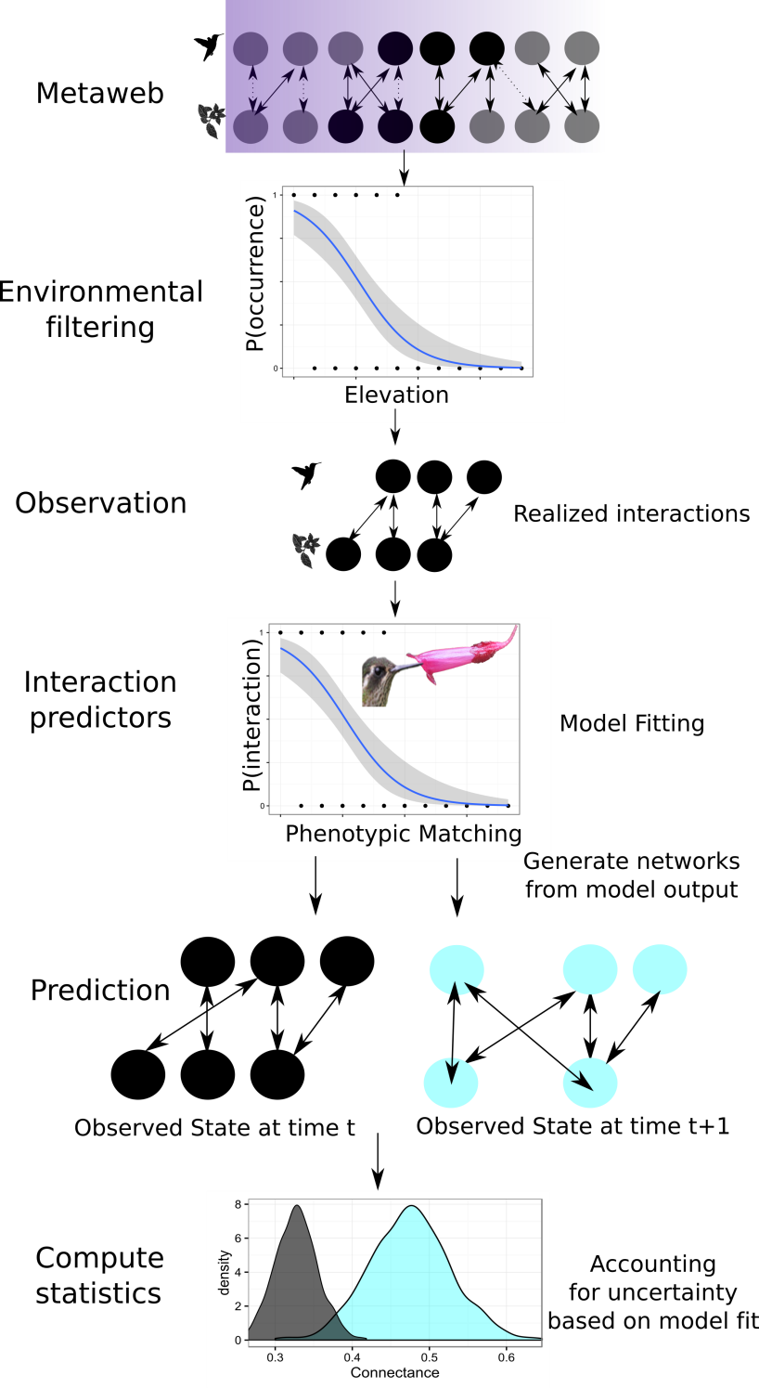Figure 1. Conceptual overview of the scaling of species interactions. Abiotic and biotic filter interactions from a meta-web into a set of realized interactions at the local scale. These local observations can be used to evaluate the importance of these filters and build predictive models of interaction strength. By comparing the fitted parameters from these models we can generate many realizations of interactions to calculate network statistics.

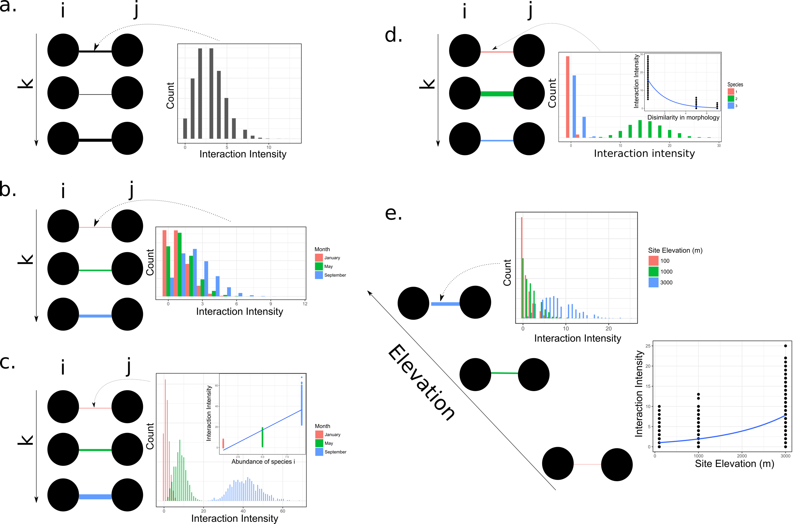

Figure 2. Frequency of interactions between species *i* and *j* for three different samples *k* where k is ecologically short time interval and difference interaction intensity is a function of a) stochastic variation in sampling, b) variation across months, c) temporal changes in species abundance, d) the dissimilarity in partner morphology, e) elevation dependent species abundance.

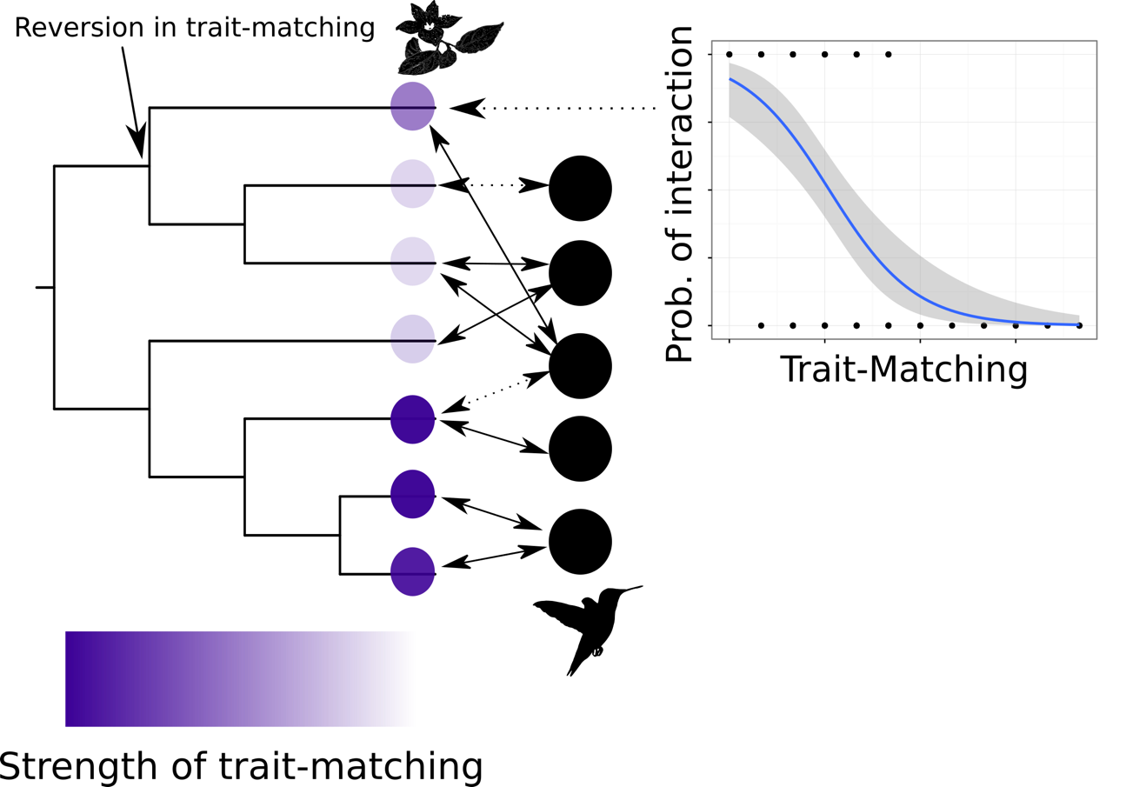

Figure 3. Mapping parameter estimates from local models of species interactions to community-level phylogenies. Here a hypothetical clade of co-occurring plants has strong trait-matching in one group, and weak trait-matching in another, with a reversion in trait matching for one species in the weak trait-matching group.

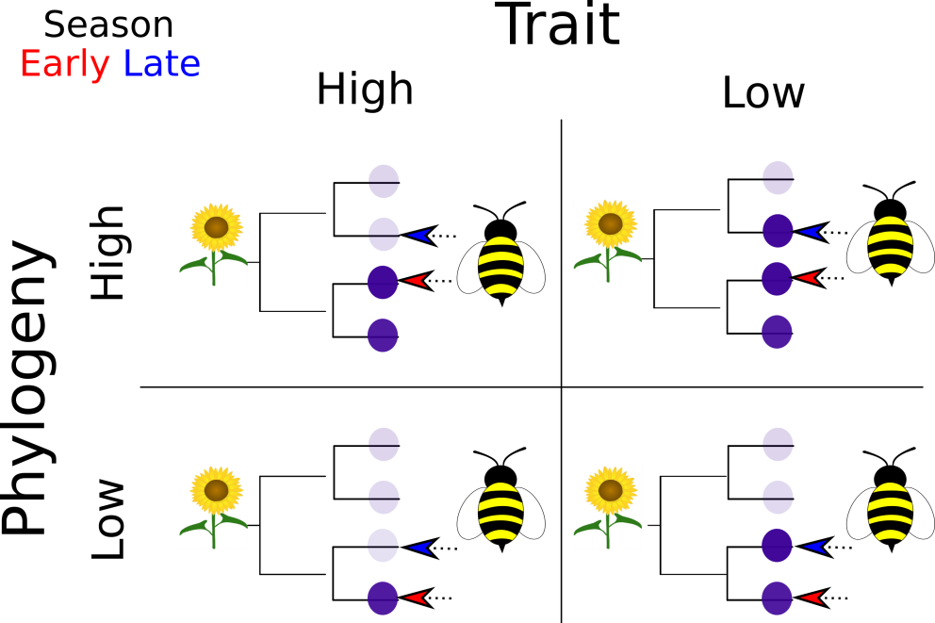

Figure 4. Possible combinations of phylogenetic and trait rewiring across a season. Species presences are stable, but their relative abundance may change. Plant species differ in a single functional trait (purple). Each realized interaction is depicted by an arrow for each season.

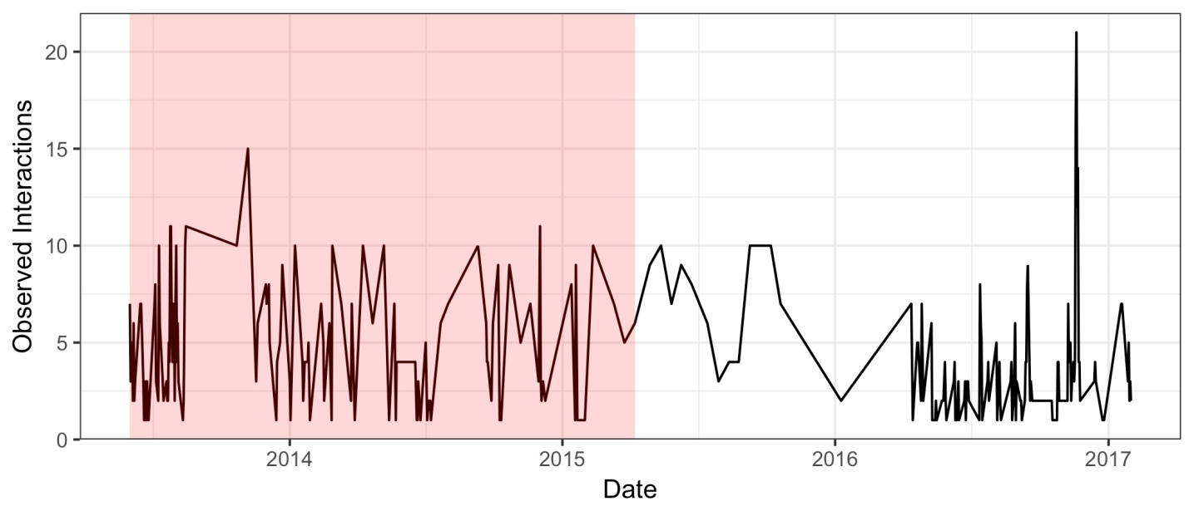Box 1. Figure 1. Time series of hummingbird-plant interactions from Northwest Ecuador. Time-lapse cameras were used to monitor interactions between 20 hummingbird species and 40 plant species. Each camera filmed individual plants from dawn to dusk for 2-5 days. The daily total number of observed links is between a hummingbird and flower is shown. The interactions in (n=597) in the red region were used to predict the interactions in the white region (n=451).

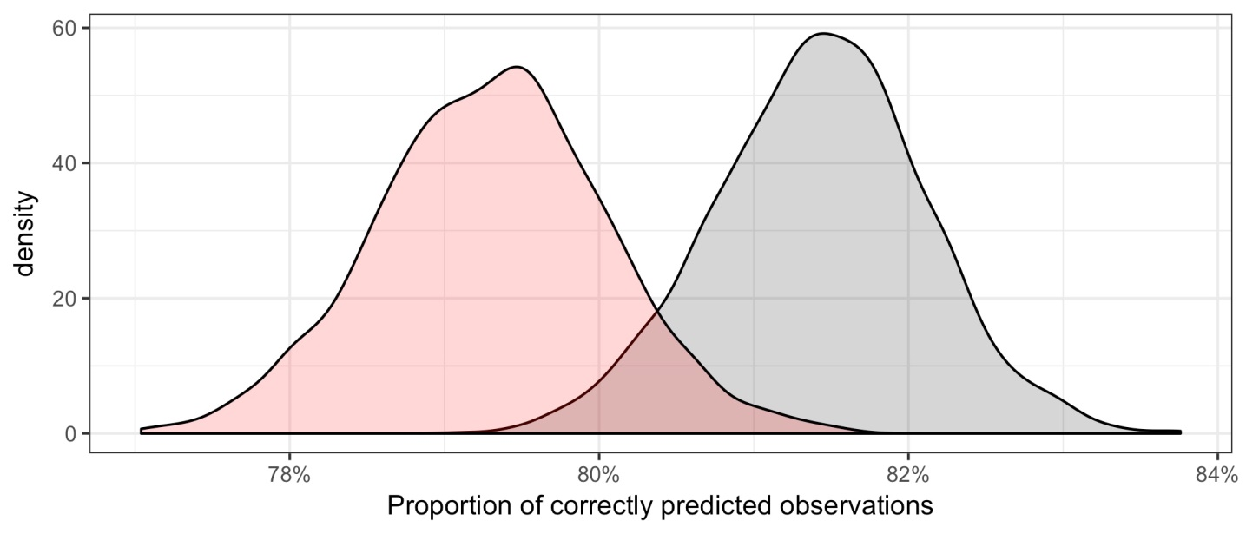Box 1. Figure 2. Prediction results of the binary trait-matching model for hummingbird-plant interactions. The proportion of correctly predicted observations when using the data from the 1st half of the time series (red) to predict the 2nd half of the time series. This is compared to the proportion of correctly predicted links when using data from the 2nd half of the time series to predict itself.

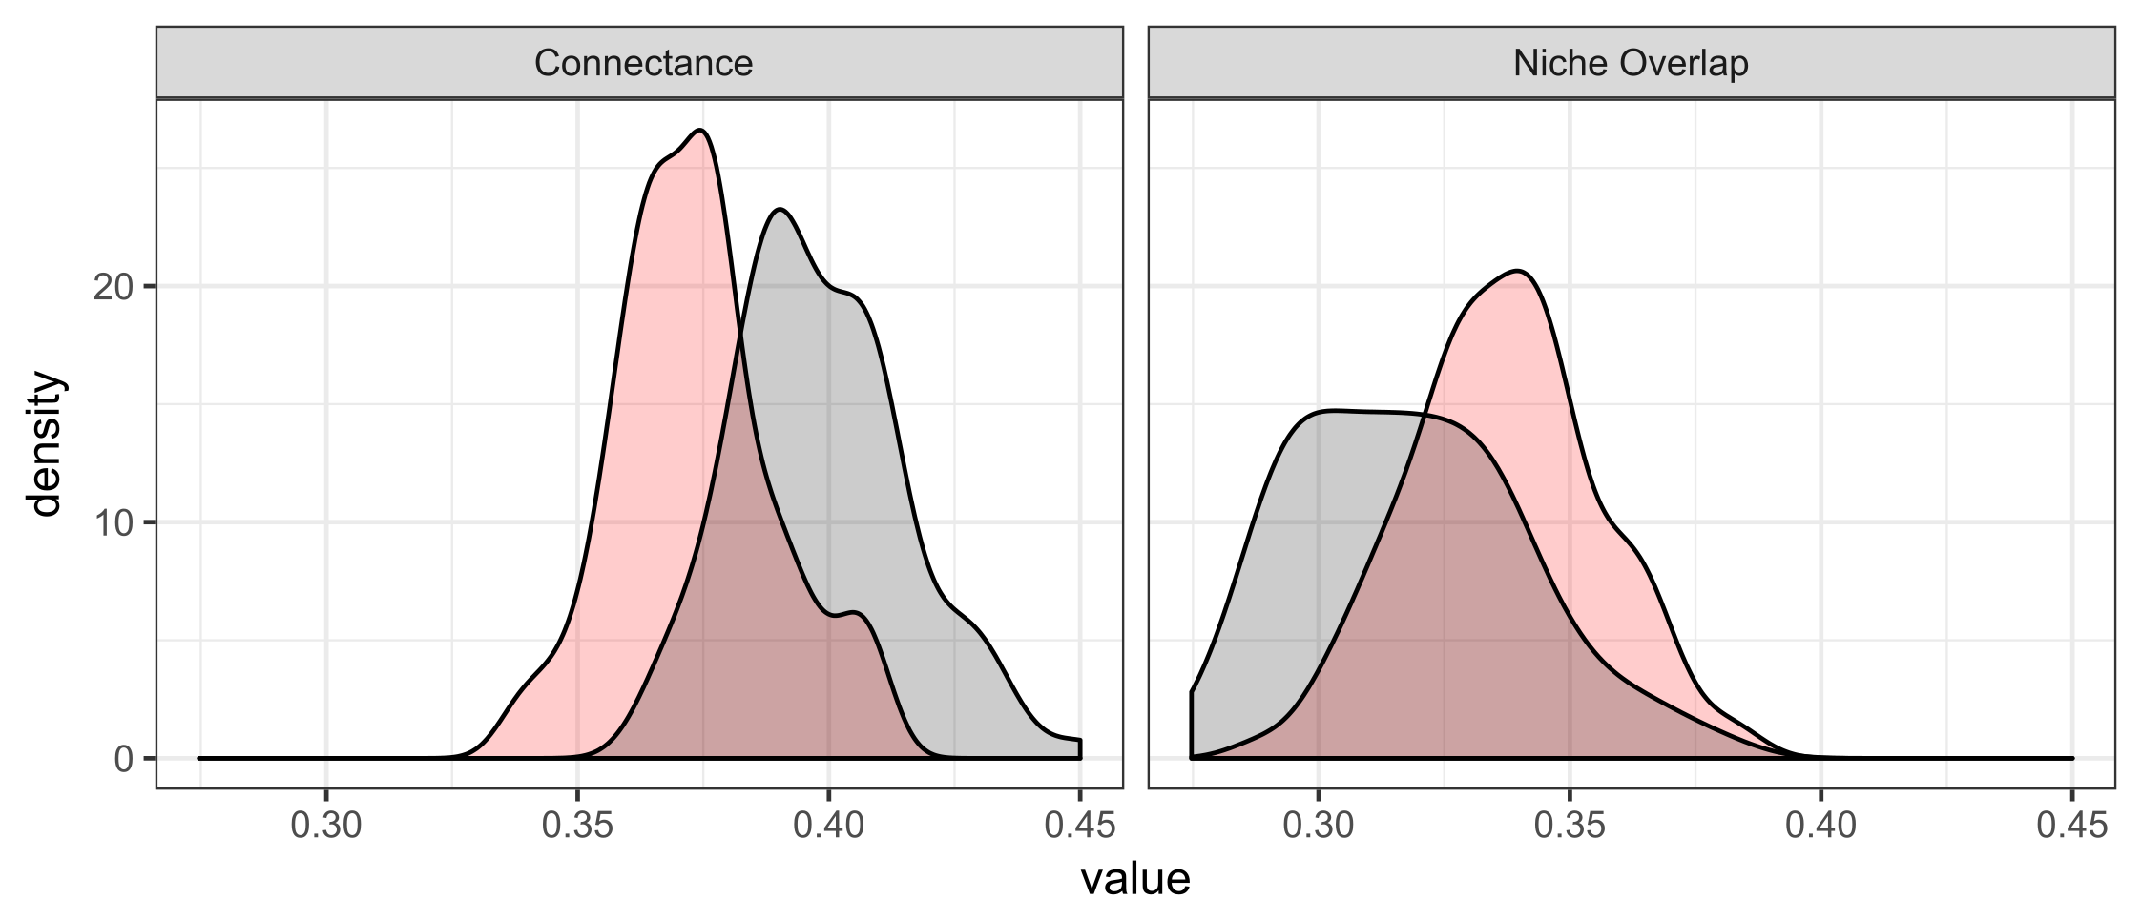Box 1. Figure 3. Network level results of the binary trait-matching model for hummingbird-plant interactions. One hundred networks were generated from the posterior distribution of fitted model parameters. For each draw, each link among species was a binomial draw based on the estimated probability of interaction due to trait matching. From each of these networks we calculated connectance and niche overlap of the lower level (plants). Network statistics from the predicted observations when using the data from the 1st half of the time series to predict the 2nd half of the time series (red) are compared to the network statistics when using data from the 2nd half of the time series to predict itself.